1. RegEX symbols in linux

. – Matches **any single character**

* – Matches **zero or more** of the **preceding** character

^ – Matches the **beginning** of a line

$ – Matches the **end** of a line

[] – Matches **any one** character inside the brackets

[^] – Matches **any one** character **not** inside the brackets

\ – Escapes a special character

1. imp features of Linux OS

Open Source - Source code is freely available to view, modify, and distribute.

Multiuser - Multiple users can access system resources (CPU, memory, storage) at the same time without interfering with each other.

Multitasking – Linux can run multiple tasks/processes simultaneously without performance loss.  
Security – Provides strong security through user authentication, file permissions, and encryption.  
Portability – Can run on a wide variety of hardware platforms from desktops to servers and embedded systems.  
Stability and Reliability – Rarely crashes and can run for long periods without needing a reboot.  
Shell/Command Line Interface – Offers a powerful CLI for system control, scripting, and automation.  
Programming Support – Supports a wide range of programming languages like C, C++, Python, Java, etc.  
File System Support – Supports various file systems.  
Modularity and Customization – Highly customizable; users can add or remove components as needed.

1. What is a Kernal and explain its functions

It acts as a bridge between the hardware and the software. It manages system resources and allows software applications to interact with the hardware in a controlled way.

Func:

- Handles the creation, scheduling, and termination of processes.

- Ensures each process gets fair CPU time

- Ensures each process gets fair CPU time

- Manages file operations and Handles file permissions and directory structures

4. What is BASH? Full form with explaination

**BASH** stands for **Bourne Again Shell**

**BASH is a shell – A shell is a program that takes user commands and passes them to the operating system to execute.  
BASH is an improved version of the Bourne Shell with additional feature**

1. What is the diffrenece between window and linux

Windows:

Closed-source

GUI-focused and less terminal use

PowerShell or CMD

Linux:

Open-source and freely available

CLI-focused, GUI optional

BASH or other shells

1. basic components of Linux

**Kernel – Core of the system**

**Shell – Command interpreter**

**File System – Manages data storage**

**System Libraries – Interface for apps to talk to the kernel**

**System Utilities – Basic tools for managing the system**

**User Interface – CLI or GUI for user interaction**

1. Is it legal to edit Kernal

Yes, it is legal to edit the Linux kernel

1. LILO

**LILO stands for LInux LOader.**

**It is a boot loader for Linux — a small program that loads the Linux operating system into the computer’s memory when you turn it on.**

1. What is shell? How many shells are there and what are they

**A shell is a command-line interpreter that provides a user interface for accessing the operating system’s services. It takes commands typed by the user and executes them by interacting with the kernel.**

**the shell is the bridge between user and the Linux OS, it lets you control the computer by typing commands or running scripts.**

Bash - Bourne Again Shell

Sh - Bourne Shell

Csh - C Shell

Zsh - Z Shell

1. What is Swap space

**Swap space is a special area on a hard disk or SSD that the Linux operating system uses as virtual memory when the system’s physical RAM is full**

1. What is mount? how do you mount and unmount file system in Linux

**Mounting is the process of making a file system accessible at a certain point in the directory tree. When you mount a storage device, you attach its file system to a directory so you can access its files.**

**sudo mount /dev/sdb1 /mnt/usb**

**sudo umount device**

1. What is chmod command? how to use it

**The chmod command in Linux is used to change the permissions of files and directories. Permissions control who can read, write, or execute a file.**

**chmod u+x file.sh**: Adds execute permission for the **user** (owner) to the file file.sh.

**chmod g-w directory**: Removes write permission for the **group** from the directory.

**chmod o=r directory**: Sets the permissions for **others** to **read-only** on the directory.

**chmod a+r file.txt**: Adds read permission for **all users** (user, group, others) to the file file.txt.

**chmod 755 script.sh**: Sets permissions to **rwx for owner**, **r-x for group**, and **r-x for others** on script.sh.

**chmod 644 report.txt**: Sets permissions to **rw- for owner**, **r-- for group**, and **r-- for others** on report.txt.

1. Can you add a new user account?

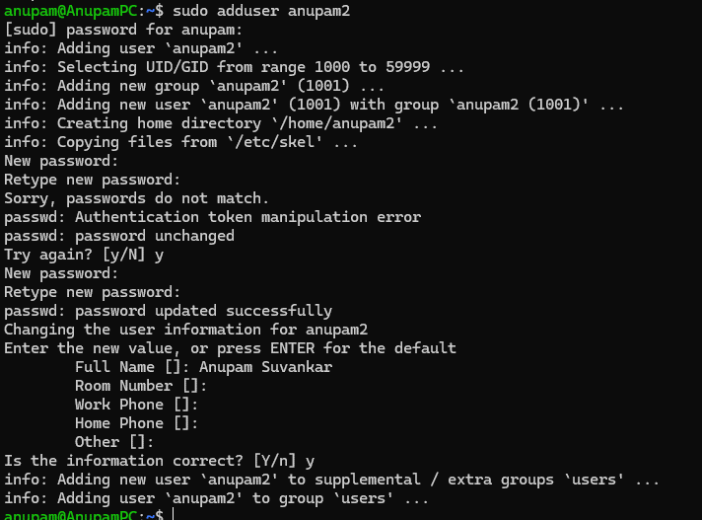

1. **Change password**

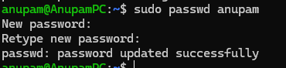

1. What is diff between Process and Thread

Process

An independent program in execution with its own **memory space**.

Has its own **address space, resources, and data**.

Processes don’t share memory with other processes

Communication between processes requires **inter-process communication**

Thread

The smallest unit of execution inside a process

Shares the same **memory space and resources** with other threads of the same process

Lightweight, easier and faster to create than processes

1. **GREP**

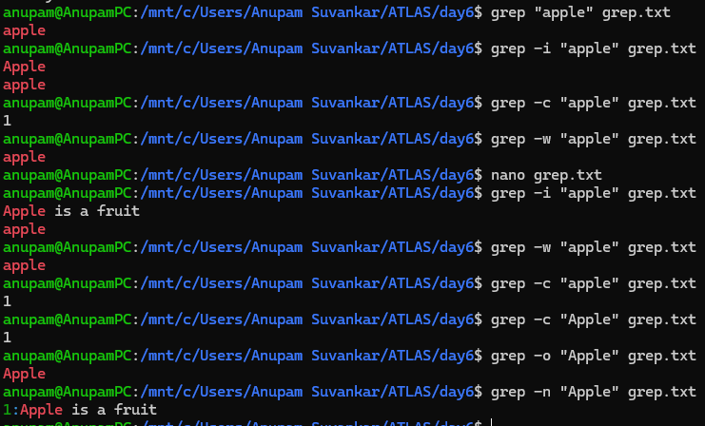

1. AWT

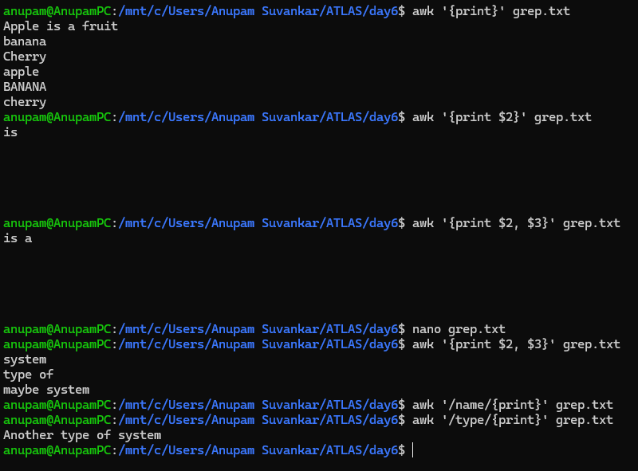

1. check file access permission in Linux

use ls -l command to check file access permissions

read r, write w, and execute x

1. What are the default permissions for a new file

Read and Write

1. change the permisssion to read only for the owner

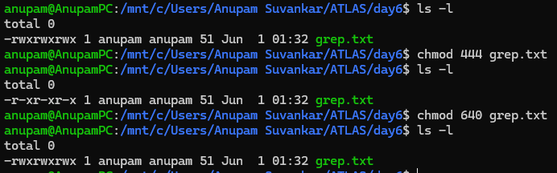

1. Can you change the file permissions to match the following:
   1. owner: Read and Write
   2. group: Read
   3. other: no permissions (None)
2. command for changing teh file permissions to -rw-r-----?

chmod 640

1. Change chmod.exercises permissions to -rwxr-x--x

Change the file permissions to match the following:

owner: Read, Write and Execute

group: Read and Execute

other: Execute

Chmod u=rwx,g=rx.0=x grep. txt

chmod 751 grep. txt

Owner: 7=4+2+1: rwx

Group: 5=4+0+1: r-x

Others: 1=0+0+1

1. command for changing the file permissions to -rwxr-x—x

chmod 751

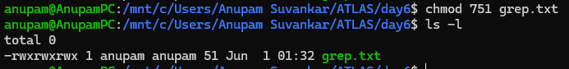

1. Guys what will this command do?

chown -c master file1.txt

It changes the ownership of a file or directory to master

1. what is a process

when you run a program (like a browser, editor, or script), the operating system creates a process for it

1. check foreground process and background process



1. list all the running processes

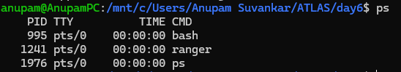

1. What will ps -f command do?

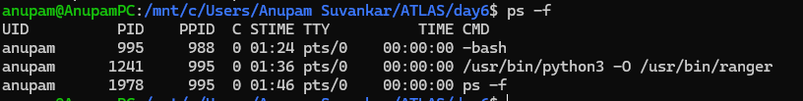

processes in full-format listing

1. create a variable name with your name in it

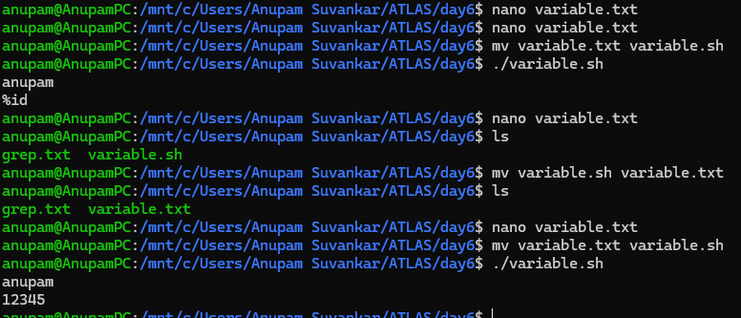

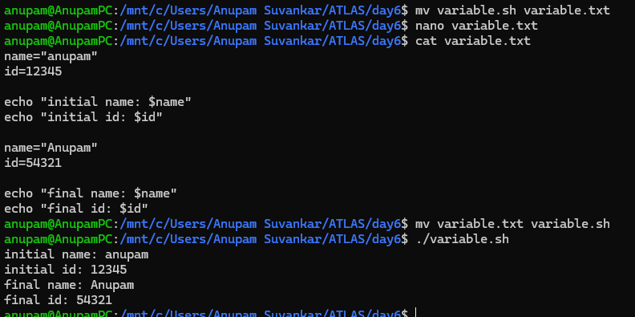

1. unset or delete the variables

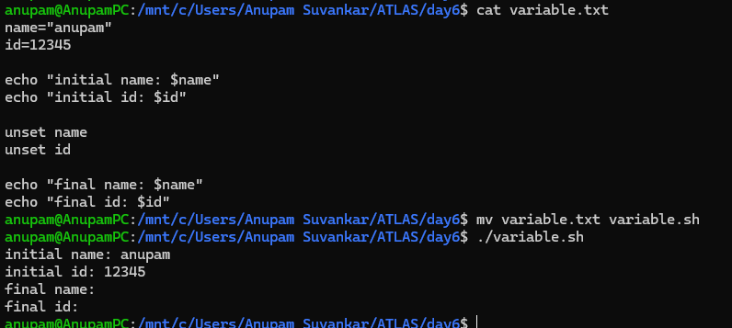

1. add a list of your friends names in an array and try to printout
2. print all the list at once in an array

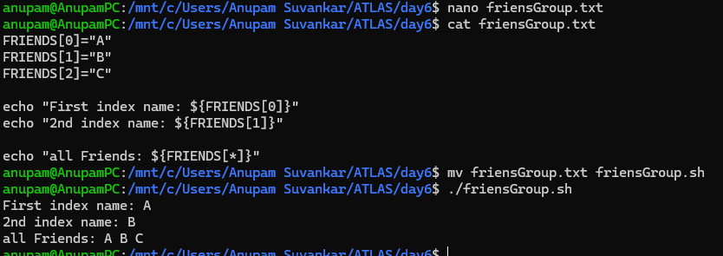

1. whats the output of the below snippet:

a=0

while [ "$a" -lt 10 ]    # this is loop1

do

   b="$a"

   while [ "$b" -ge 0 ]  # this is loop2

   do

      echo -n "$b "

      b=`expr $b - 1`

   done

   echo

   a=`expr $a + 1`

done

